**1. Status**

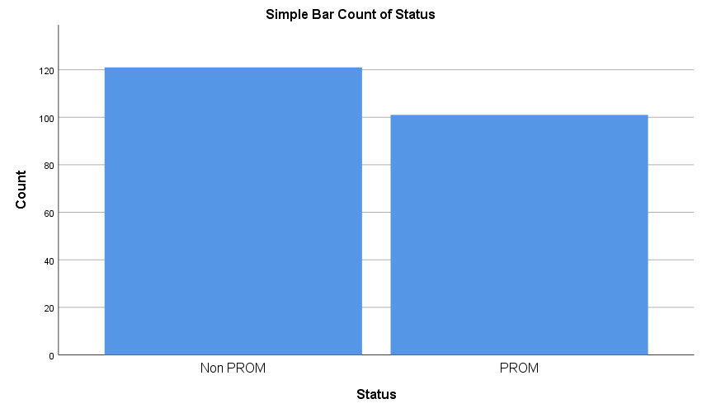

|  |  |  |  |  |  |
| --- | --- | --- | --- | --- | --- |
| **Status** | | | | | |
|  | | Frequency | Percent | Valid Percent | Cumulative Percent |
| Valid | Non PROM | 121 | 54.5 | 54.5 | 54.5 |
| PROM | 101 | 45.5 | 45.5 | 100.0 |
| Total | 222 | 100.0 | 100.0 |  |

**2. Patient Age**

|  |  |  |  |  |  |
| --- | --- | --- | --- | --- | --- |
| **Patient Age** | | | | | |
|  | | Frequency | Percent | Valid Percent | Cumulative Percent |
| Valid | <= 20 | 69 | 31.1 | 31.1 | 31.1 |
| 21 - 25 | 85 | 38.3 | 38.3 | 69.4 |
| 26 - 30 | 48 | 21.6 | 21.6 | 91.0 |
| 31 - 35 | 15 | 6.8 | 6.8 | 97.7 |
| 36+ | 5 | 2.3 | 2.3 | 100.0 |
| Total | 222 | 100.0 | 100.0 |  |

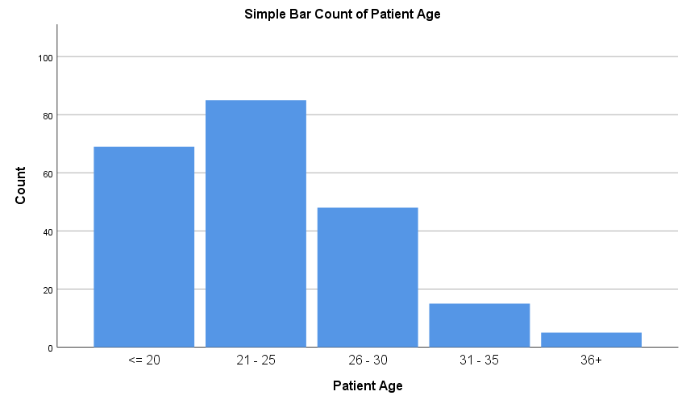

|  |  |  |  |
| --- | --- | --- | --- |
| **Chi-Square Tests** | | | |
|  | Value | df | Asymptotic Significance (2-sided) |
| Pearson Chi-Square | 1.933a | 4 | .748 |
| Likelihood Ratio | 1.930 | 4 | .749 |
| N of Valid Cases | 222 |  |  |
| a. 2 cells (20.0%) have expected count less than 5. The minimum expected count is 2.27. | | | |

**3. Patient Occupation**

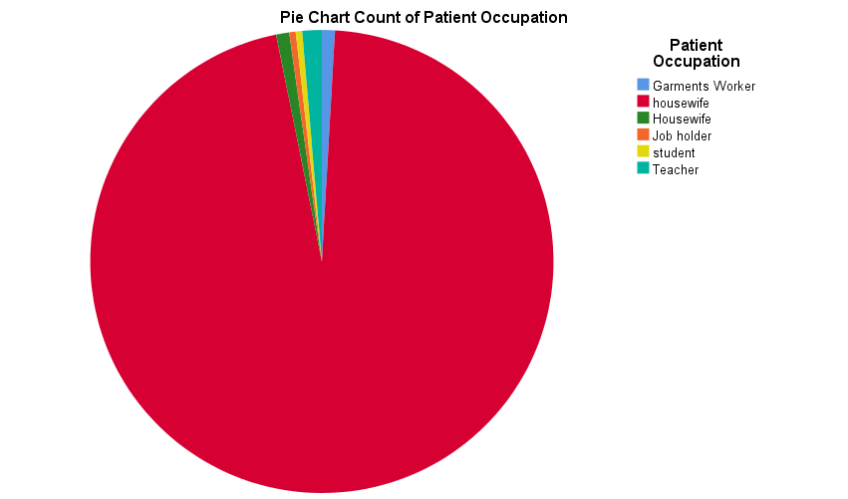

|  |  |  |  |  |  |  |  |  |  |
| --- | --- | --- | --- | --- | --- | --- | --- | --- | --- |
| **Crosstab** | | | | | | | | | |
| Count | | | | | | | | | |
|  | | Patient Occupation | | | | | | | Total |
|  | Garments Worker | housewife | Housewife | Job holder | student | Teacher |
| Status | Non PROM | 1 | 1 | 116 | 1 | 0 | 1 | 1 | 121 |
| PROM | 0 | 1 | 96 | 1 | 1 | 0 | 2 | 101 |
| Total | | 1 | 2 | 212 | 2 | 1 | 1 | 3 | 222 |

|  |  |  |  |
| --- | --- | --- | --- |
| **Chi-Square Tests** | | | |
|  | Value | df | Asymptotic Significance (2-sided) |
| Pearson Chi-Square | 3.446a | 6 | .751 |
| Likelihood Ratio | 4.584 | 6 | .598 |
| N of Valid Cases | 222 |  |  |
| a. 12 cells (85.7%) have expected count less than 5. The minimum expected count is .45. | | | |

**4. Educational Status**

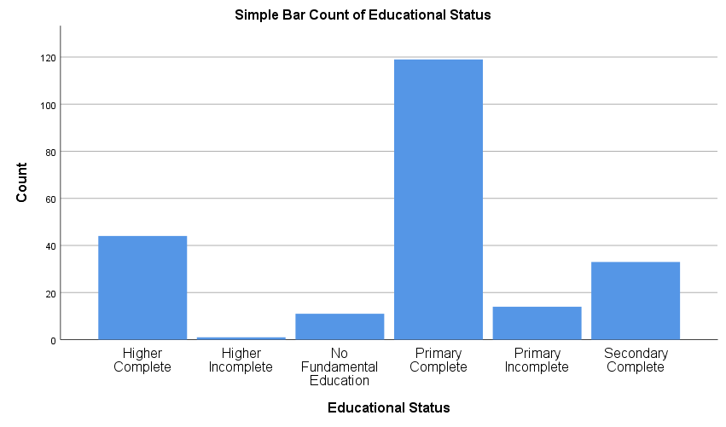

|  |  |  |  |  |  |  |  |  |
| --- | --- | --- | --- | --- | --- | --- | --- | --- |
| **Crosstab** | | | | | | | | |
| Count | | | | | | | | |
|  | | Educational Status | | | | | | Total |
| Higher Complete | Higher Incomplete | No Fundamental Education | Primary Complete | Primary Incomplete | Secondary Complete |
| Status | Non PROM | 24 | 0 | 5 | 60 | 9 | 23 | 121 |
| PROM | 20 | 1 | 6 | 59 | 5 | 10 | 101 |
| Total | | 44 | 1 | 11 | 119 | 14 | 33 | 222 |

|  |  |  |  |
| --- | --- | --- | --- |
| **Chi-Square Tests** | | | |
|  | Value | df | Asymptotic Significance (2-sided) |
| Pearson Chi-Square | 5.974a | 5 | .309 |
| Likelihood Ratio | 6.467 | 5 | .263 |
| N of Valid Cases | 222 |  |  |
| a. 2 cells (16.7%) have expected count less than 5. The minimum expected count is .45. | | | |

**5. Husband’s Educational Status**

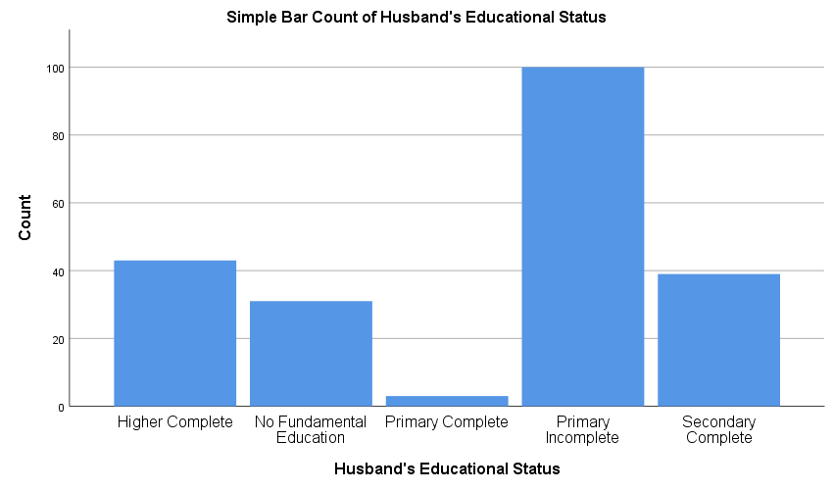

**6. Religion**

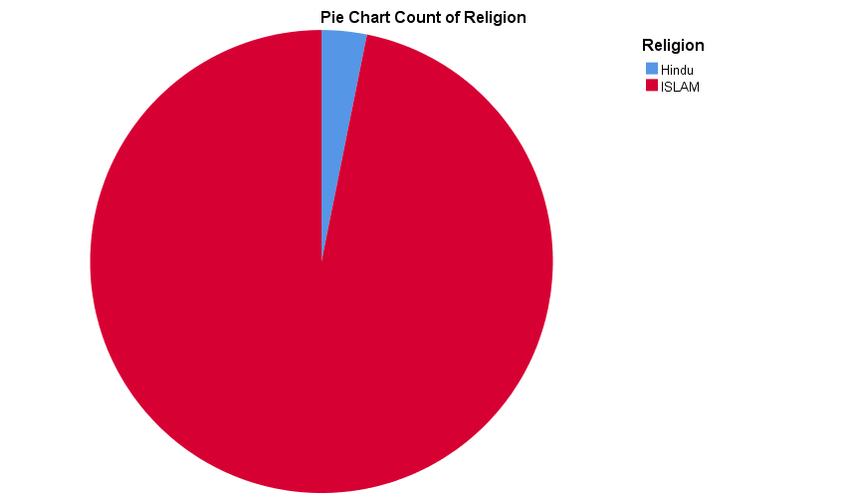

|  |  |  |  |  |
| --- | --- | --- | --- | --- |
| **Crosstab** | | | | |
| Count | | | | |
|  | | Religion | | Total |
| Hindu | ISLAM |
| Status | Non PROM | 3 | 118 | 121 |
| PROM | 4 | 97 | 101 |
| Total | | 7 | 215 | 222 |

|  |  |  |  |  |  |
| --- | --- | --- | --- | --- | --- |
| **Chi-Square Tests** | | | | | |
|  | Value | df | Asymptotic Significance (2-sided) | Exact Sig. (2-sided) | Exact Sig. (1-sided) |
| Pearson Chi-Square | .395a | 1 | .529 |  |  |
| Continuity Correctionb | .059 | 1 | .808 |  |  |
| Likelihood Ratio | .394 | 1 | .530 |  |  |
| Fisher's Exact Test |  |  |  | .705 | .401 |
| N of Valid Cases | 222 |  |  |  |  |
| a. 2 cells (50.0%) have expected count less than 5. The minimum expected count is 3.18. | | | | | |
| b. Computed only for a 2x2 table | | | | | |

**7. Economic Condition**

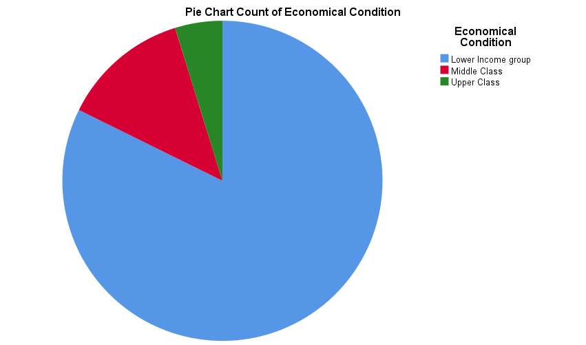

|  |  |  |  |  |  |  |
| --- | --- | --- | --- | --- | --- | --- |
| **Crosstab** | | | | | | |
| Count | | | | | | |
|  | | Economical Condition | | | | Total |
|  | Lower Income group | Middle Class | Upper Class |
| Status | Non PROM | 7 | 92 | 17 | 5 | 121 |
| PROM | 6 | 80 | 10 | 5 | 101 |
| Total | | 13 | 172 | 27 | 10 | 222 |

|  |  |  |  |
| --- | --- | --- | --- |
| **Chi-Square Tests** | | | |
|  | Value | df | Asymptotic Significance (2-sided) |
| Pearson Chi-Square | .935a | 3 | .817 |
| Likelihood Ratio | .946 | 3 | .814 |
| N of Valid Cases | 222 |  |  |
| a. 1 cells (12.5%) have expected count less than 5. The minimum expected count is 4.55. | | | |

**Association with Prom Status**

**1.**

|  |  |  |  |  |
| --- | --- | --- | --- | --- |
| **Status * Are husband and wife blood relatives ? Crosstabulation** | | | | |
| Count | | | | |
|  | | Are husband and wife blood relatives ? | | Total |
| No | Yes |
| Status | Non PROM | 113 | 8 | 121 |
| PROM | 98 | 3 | 101 |
| Total | | 211 | 11 | 222 |

|  |  |  |  |  |
| --- | --- | --- | --- | --- |
| **Chi-Square Tests** | | | | |
|  | Value | df | Asymptotic Significance (2-sided) |
| Pearson Chi-Square | 1.550a | 1 | .213 |

Comment: There is no statistically significant association between status and wife & husband being blood relatives.

**2.**

|  |  |  |  |  |  |
| --- | --- | --- | --- | --- | --- |
| **Status * Is there any one with congenital anomalies? Crosstabulation** | | | | | |
| Count | | | | | |
|  | | Is there any one with congenital anomalies? | | | Total |
| debors son | No | Yes |
| Status | Non PROM | 0 | 119 | 2 | 121 |
| PROM | 1 | 99 | 1 | 101 |
| Total | | 1 | 218 | 3 | 222 |

|  |  |  |  |
| --- | --- | --- | --- |
| **Chi-Square Tests** | | | |
|  | Value | df | Asymptotic Significance (2-sided) |
| Pearson Chi-Square | 1.378a | 2 | .502 |

Comment: There is no statistically significant association between status and having congenital anomalies.

**3.**

|  |  |  |  |
| --- | --- | --- | --- |
| **Status * Whether her husband has any sexually transmitted diseases as per the wife's knowledge Crosstabulation** | | | |
| Count | | | |
|  | | Whether her husband has any sexually transmitted diseases as per the wife's knowledge | Total |
| No |
| Status | Non PROM | 121 | 121 |
| PROM | 101 | 101 |
| Total | | 222 | 222 |

**4.**

|  |  |  |  |  |  |
| --- | --- | --- | --- | --- | --- |
| **Status * any Itching/white discharge/malodorous discharge PV Crosstabulation** | | | | | |
| Count | | | | | |
|  | | any Itching/white discharge/malodorous discharge PV | | | Total |
|  | No | Yes |
| Status | Non PROM | 3 | 91 | 27 | 121 |
| PROM | 1 | 81 | 19 | 101 |
| Total | | 4 | 172 | 46 | 222 |

|  |  |  |  |
| --- | --- | --- | --- |
| **Chi-Square Tests** | | | |
|  | Value | df | Asymptotic Significance (2-sided) |
| Pearson Chi-Square | 1.180a | 2 | .554 |

Comment: There is no statistically significant association between status and having any Itching/white discharge/malodorous discharge PV.

**5.**

|  |  |  |  |
| --- | --- | --- | --- |
| **Status * Polyhydramnios Crosstabulation** | | | |
| Count | | | |
|  | | Polyhydramnios | Total |
| No |
| Status | Non PROM | 121 | 121 |
| PROM | 101 | 101 |
| Total | | 222 | 222 |

**6.**

|  |  |  |  |  |  |
| --- | --- | --- | --- | --- | --- |
| **Status * Hypothyroidism Crosstabulation** | | | | | |
| Count | | | | | |
|  | | Hypothyroidism | | | Total |
|  | No | Yes |
| Status | Non PROM | 0 | 116 | 5 | 121 |
| PROM | 1 | 97 | 3 | 101 |
| Total | | 1 | 213 | 8 | 222 |

|  |  |  |  |
| --- | --- | --- | --- |
| **Chi-Square Tests** | | | |
|  | Value | df | Asymptotic Significance (2-sided) |
| Pearson Chi-Square | 1.404a | 2 | .495 |
|  | | | |

Comment: There is no statistically significant association between status and hypothyroidism.

**7.**

|  |  |  |  |  |  |
| --- | --- | --- | --- | --- | --- |
| **Status * Does the wife have habit of Betel ? Crosstabulation** | | | | | |
| Count | | | | | |
|  | | Does the wife have habit of Betel ? | | | Total |
|  | No | Yes |
| Status | Non PROM | 5 | 104 | 12 | 121 |
| PROM | 3 | 84 | 14 | 101 |
| Total | | 8 | 188 | 26 | 222 |

|  |  |  |  |
| --- | --- | --- | --- |
| **Chi-Square Tests** | | | |
|  | Value | df | Asymptotic Significance (2-sided) |
| Pearson Chi-Square | .988a | 2 | .610 |
|  | | | |

Comment: There is no statistically significant association between status and wife having a habit of betel.

**8.**

|  |  |  |  |  |  |
| --- | --- | --- | --- | --- | --- |
| **Status * Does the husband have habit of smoking? Crosstabulation** | | | | | |
| Count | | | | | |
|  | | Does the husband have habit of smoking? | | | Total |
|  | No | Yes |
| Status | Non PROM | 6 | 63 | 52 | 121 |
| PROM | 2 | 50 | 49 | 101 |
| Total | | 8 | 113 | 101 | 222 |

|  |  |  |  |
| --- | --- | --- | --- |
| **Chi-Square Tests** | | | |
|  | Value | df | Asymptotic Significance (2-sided) |
| Pearson Chi-Square | 1.797a | 2 | .407 |
|  | | | |

Comment: There is no statistically significant association between status and husband having a habit of smoking.

**9.**

|  |  |  |  |  |  |
| --- | --- | --- | --- | --- | --- |
| **Status * Does the husband have habit of betel ? Crosstabulation** | | | | | |
| Count | | | | | |
|  | | Does the husband have habit of betel ? | | | Total |
|  | No | Yes |
| Status | Non PROM | 5 | 92 | 24 | 121 |
| PROM | 2 | 77 | 22 | 101 |
| Total | | 7 | 169 | 46 | 222 |

|  |  |  |  |
| --- | --- | --- | --- |
| **Chi-Square Tests** | | | |
|  | Value | df | Asymptotic Significance (2-sided) |
| Pearson Chi-Square | .910a | 2 | .635 |
|  | | | |

Comment: There is no statistically significant association between status and husband having a habit of betel.

**10.**

|  |  |  |  |  |  |  |  |
| --- | --- | --- | --- | --- | --- | --- | --- |
| **Crosstab** | | | | | | | |
| Count | | | | | | | |
|  | | Nutritional status | | | | | Total |
|  | average | bellow average | good | not good |
| Status | Non PROM | 3 | 19 | 1 | 98 | 0 | 121 |
| PROM | 6 | 16 | 2 | 75 | 2 | 101 |
| Total | | 9 | 35 | 3 | 173 | 2 | 222 |

|  |  |  |  |
| --- | --- | --- | --- |
| **Chi-Square Tests** | | | |
|  | Value | df | Asymptotic Significance (2-sided) |
| Pearson Chi-Square | 4.886a | 4 | .299 |
|  | | | |

Comment: There is no statistically significant association between status and nutritional status.

**11.**

|  |  |  |  |  |  |  |
| --- | --- | --- | --- | --- | --- | --- |
| **Crosstab** | | | | | | |
| Count | | | | | | |
|  | | Anemia | | | | Total |
|  | Absent | Mild | Positive |
| Status | Non PROM | 3 | 29 | 37 | 52 | 121 |
| PROM | 4 | 23 | 33 | 41 | 101 |
| Total | | 7 | 52 | 70 | 93 | 222 |

|  |  |  |  |
| --- | --- | --- | --- |
| **Chi-Square Tests** | | | |
|  | Value | df | Asymptotic Significance (2-sided) |
| Pearson Chi-Square | .568a | 3 | .904 |
|  | | | |

Comment: There is no statistically significant association between status and anemia.

**12.**

|  |  |  |  |  |  |
| --- | --- | --- | --- | --- | --- |
| **Crosstab** | | | | | |
| Count | | | | | |
|  | | Oedema | | | Total |
|  | Negative | Positive |
| Status | Non PROM | 3 | 109 | 9 | 121 |
| PROM | 4 | 95 | 2 | 101 |
| Total | | 7 | 204 | 11 | 222 |

|  |  |  |  |
| --- | --- | --- | --- |
| **Chi-Square Tests** | | | |
|  | Value | df | Asymptotic Significance (2-sided) |
| Pearson Chi-Square | 3.787a | 2 | .151 |
|  | | | |

Comment: There is no statistically significant association between status and oedema.

**13.**

|  |  |  |  |  |
| --- | --- | --- | --- | --- |
| **Status * Diabetic Crosstabulation** | | | | |
| Count | | | | |
|  | | Diabetic | | Total |
| 0 | 1 |
| Status | Non PROM | 112 | 9 | 121 |
| PROM | 93 | 8 | 101 |
| Total | | 205 | 17 | 222 |

|  |  |  |  |  |  |
| --- | --- | --- | --- | --- | --- |
| **Chi-Square Tests** | | | | | |
|  | Value | df | Asymptotic Significance (2-sided) | Exact Sig. (2-sided) | Exact Sig. (1-sided) |
| Pearson Chi-Square | .018a | 1 | .893 |  |  |
| Continuity Correctionb | .000 | 1 | 1.000 |  |  |
| Likelihood Ratio | .018 | 1 | .893 |  |  |
| Fisher's Exact Test |  |  |  | 1.000 | .544 |
| N of Valid Cases | 222 |  |  |  |  |
| a. 0 cells (0.0%) have expected count less than 5. The minimum expected count is 7.73. | | | | | |
| b. Computed only for a 2x2 table | | | | | |

**14.**

|  |  |  |  |  |  |
| --- | --- | --- | --- | --- | --- |
| **Group Statistics** | | | | | |
|  | Status | N | Mean | Std. Deviation | Std. Error Mean |
| Hemoglobin | Non PROM | 117 | 10.5425 | 1.23523 | .11420 |
| PROM | 95 | 10.5874 | .96329 | .09883 |
| Total count | Non PROM | 99 | 10042.08 | 2994.023 | 300.911 |
| PROM | 86 | 11104.07 | 10777.491 | 1162.167 |
| Lymphocyte: | Non PROM | 110 | 26.618181818181817 | 11.104988397386482 | 1.058819099091438 |
| PROM | 92 | 27.934782608695652 | 9.715518737968967 | 1.012912848454065 |
| Neutroplil: | Non PROM | 110 | 68.509090909090920 | 10.869320053804040 | 1.036349004183904 |
| PROM | 91 | 66.758241758241750 | 9.338499355226737 | .978940727182160 |
| Platelet | Non PROM | 104 | 229590.38 | 62134.556 | 6092.794 |
| PROM | 89 | 227353.93 | 66984.318 | 7100.324 |

**Status * Epithelial Cells**

|  |  |  |  |
| --- | --- | --- | --- |
| **Chi-Square Tests** | | | |
|  | Value | df | Asymptotic Significance (2-sided) |
| Pearson Chi-Square | 29.674a | 27 | .329 |
| Likelihood Ratio | 36.101 | 27 | .113 |
| N of Valid Cases | 222 |  |  |
| a. 41 cells (73.2%) have expected count less than 5. The minimum expected count is .45. | | | |

**Status * Pus Cell:**

|  |  |  |  |
| --- | --- | --- | --- |
| **Chi-Square Tests** | | | |
|  | Value | df | Asymptotic Significance (2-sided) |
| Pearson Chi-Square | 27.048a | 25 | .353 |
| Likelihood Ratio | 31.943 | 25 | .160 |
| N of Valid Cases | 222 |  |  |
| a. 36 cells (69.2%) have expected count less than 5. The minimum expected count is .45. | | | |

**Status * RBC:**

|  |  |  |  |
| --- | --- | --- | --- |
| **Chi-Square Tests** | | | |
|  | Value | df | Asymptotic Significance (2-sided) |
| Pearson Chi-Square | 13.878a | 14 | .459 |
| Likelihood Ratio | 18.059 | 14 | .204 |
| N of Valid Cases | 222 |  |  |
| a. 22 cells (73.3%) have expected count less than 5. The minimum expected count is .45. | | | |

**Status * Urine albumin**

|  |  |  |  |
| --- | --- | --- | --- |
| **Chi-Square Tests** | | | |
|  | Value | df | Asymptotic Significance (2-sided) |
| Pearson Chi-Square | 6.470a | 8 | .595 |
| Likelihood Ratio | 7.989 | 8 | .435 |
| N of Valid Cases | 222 |  |  |
| a. 9 cells (50.0%) have expected count less than 5. The minimum expected count is .45. | | | |

**Status * Urine Sugar:**

|  |  |  |  |
| --- | --- | --- | --- |
| **Chi-Square Tests** | | | |
|  | Value | df | Asymptotic Significance (2-sided) |
| Pearson Chi-Square | 2.441a | 5 | .785 |
| Likelihood Ratio | 2.826 | 5 | .727 |
| N of Valid Cases | 222 |  |  |
| a. 4 cells (33.3%) have expected count less than 5. The minimum expected count is .45. | | | |

**Status * Urine CS: (name of organism/s &amp; Antibiotic) High Vaginal Swab CS: (name of organism/s &amp**

|  |  |  |  |
| --- | --- | --- | --- |
| **Chi-Square Tests** | | | |
|  | Value | df | Asymptotic Significance (2-sided) |
| Pearson Chi-Square | 18.908a | 17 | .334 |
| Likelihood Ratio | 25.756 | 17 | .079 |
| N of Valid Cases | 222 |  |  |
| a. 32 cells (88.9%) have expected count less than 5. The minimum expected count is .45. | | | |

|  |  |  |  |  |  |  |
| --- | --- | --- | --- | --- | --- | --- |
| **Status * Any history of injury in last 48 hours: Crosstabulation** | | | | | | |
| Count | | | | | | |
|  | | Any history of injury in last 48 hours: | | | | Total |
|  | No | white discharge | Yes |
| Status | Non PROM | 3 | 116 | 0 | 2 | 121 |
| PROM | 3 | 96 | 1 | 1 | 101 |
| Total | | 6 | 212 | 1 | 3 | 222 |

|  |  |  |  |
| --- | --- | --- | --- |
| **Chi-Square Tests** | | | |
|  | Value | df | Asymptotic Significance (2-sided) |
| Pearson Chi-Square | 1.430a | 3 | .699 |
| Likelihood Ratio | 1.811 | 3 | .612 |
| N of Valid Cases | 222 |  |  |
| a. 6 cells (75.0%) have expected count less than 5. The minimum expected count is .45. | | | |